REMINDER APP
Submitted by:
Desai Fenil
Enrollment No: 2304030100312
Desai Ronik
Enrollment No: 2304030100323
Harsh Hirpara
Enrollment No: 2304030100513
Course: Android Application Development
Program: BCA
Academic Year: 2025–2026

TABLE OF CONTENTS

- Introduction
- Problem Definition
- Objectives
- Features of Application
- Tools & Technologies
- System Working
- System Diagram
- Application Screenshots
- Conclusion

Introduction:
The Smart Reminder Application is an Android-based mobile app designed to help users manage their daily tasks efficiently. It allows users to add, edit, delete, and search reminders with specific times. The app also provides a checkbox to mark tasks as completed. This application helps users stay organized and avoid forgetting important tasks.

Problem Definition:
Many people forget their daily tasks such as meetings, assignments, shopping, or personal activities due to busy schedules. Without a proper system to manage reminders, it becomes difficult to keep track of important work. Therefore, there is a need for a simple mobile application that helps users organize their tasks and reminds them about important activities on time.

Objectives:
- To help users manage and remember their daily tasks efficiently.
- To provide a simple system for adding, editing, and deleting reminders.
- To allow users to set tasks with reminder times.
- To allow users to mark tasks as completed using a checkbox.
- To improve users time management and productivity.

Features of the Application:
- Add Task: Users can add new reminders with task name and time.
- Edit Task: Users can modify existing tasks easily.
- Delete Task: Users can remove tasks that are no longer needed.
- Search Task: Users can search tasks quickly using the search bar.
- Task Completion: Users can mark tasks as completed using a checkbox.

Tools and Technologies Used:
- Android Studio: Used as the main development environment to build the application.
- Java: Used as the programming language for application logic and functionality.
- XML: Used to design the user interface and layouts of the application.
- Android SDK: Provides libraries and tools required for Android app development.
- Android Emulator / Mobile Device: Used for testing and running the application.

System Working :
- The application allows users to add tasks with reminder time and display them in a task list.
- Users can edit or delete tasks from the list whenever required.
- The app provides a search feature to quickly find specific tasks.
- Users can mark tasks as completed using a checkbox.
- Completed tasks are shown with a check icon to indicate completion.
- The system helps users organize and manage their daily reminders efficiently.

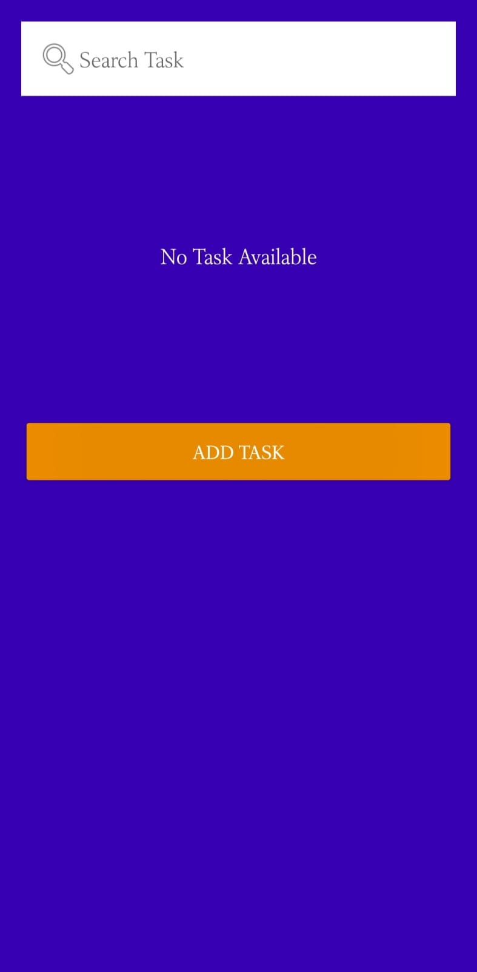
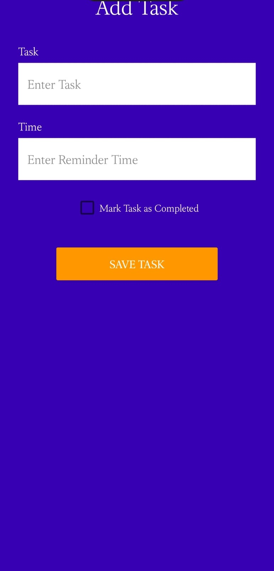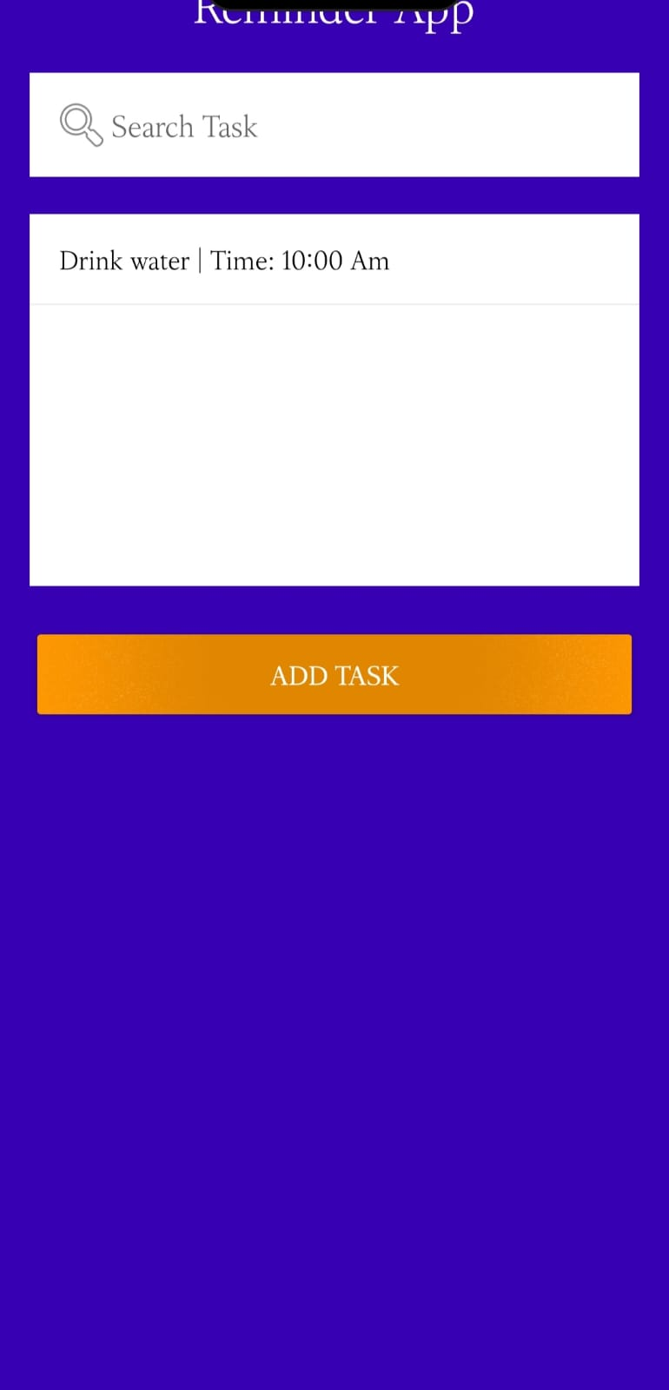
Conclusion:
The Smart Reminder Application helps users manage their daily tasks easily and efficiently. It allows users to add, edit, delete, search, and mark tasks as completed. The application improves time management and helps users remember important activities.

